PROVISIONAL MARKING KEY
AGRICULTURE II

Section A (20 marks)
- a. Income for the farmer
= 400kg x K600 per kg⁽¹⁾
= K240 000⁽¹⁾
b. Gross margin
Total variable costs = K100 000 + K 60 000 + K 30 000 = K180 000⁽¹⁾
Gross margin = Total income – Total variable costs
=K240 000 – K180 000 = K60 000⁽¹⁾
c.
Profit / Loss = Gross margin – Total fixed costs
=K60 000 – K60 000⁽¹⁾
= 0⁽¹⁾
OR

Profit / Loss = Total Income – Total costs
= K240,000 – K240,000⁽¹⁾
= 0⁽¹⁾

d.
-The farmer should increase yield of milk through proper feeding
- Increase price of milk per litre
- Reduce costs/Practise input substitution (2 marks x 2)
e.
- it helps the farmer to manage the cattle properly
- it helps in detecting/calculating profit/losses
- it helps in decision making
- it helps the farmer to easily calculate income from the farm (2 marks x 2)
- a.
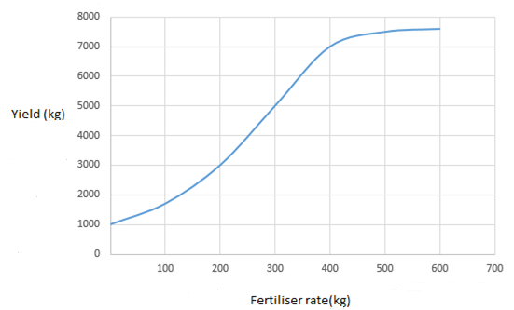
1 mark _ scale in vertical axis
1 mark _ scale in vertical axis
1 mark _ for labelling both axes
1 mark _ plotting points on the graph
1 mark _ joining points using free hands
b. 400kg/ha (1 mark)
c. It is giving maximum/highest marginal yield which will eventually reduce cost of production (2 marks)
d. - law of diminishing returns (1 mark)
e. - it helps the farmer to decide on the best level of inputs to use
- it helps farmers to use resources wisely (1 mark)

Section B (20 marks)
- a. - inelastic (1 mark)
b. (i) - complementary (1 mark)
(ii) - each crop acts as a barrier for pests for the other⁽¹⁾/ resulting in increased survival rate⁽¹⁾
- beans fix nitrogen⁽¹⁾/ which promotes health maize growth⁽¹⁾
- it reduces the risk of crop failure⁽¹⁾/ since if one crop fails the farmer relies on the other crop⁽¹⁾ (4 marks x 2)
c. - dehusking
- shelling
- drying
- cleaning (4 marks in that order)

- a. – integrated farming/ integrated forest farm and fish system (1 mark)
b. - Requires more land
- Need a lot of skill
- Requires high cost in investment
- Needs more labour (2 marks x 2)

c. - Fruit trees will absorb CO₂ from atmosphere / reducing global warming
- Water drained from fish pond will be used to irrigate groundnuts and oranges
- Poultry wastes will be used to produce biogas / to replace firewood cutting or deforestation
- Manure from poultry will fertilize soil / for high production of fruits and groundnuts (4 marks x 2)

d. - fats and oils (1 mark)
e. - it provides proteins/ for good health and growth of the goats
- to maintain the bodies of goats to avoid weight loss (2 marks x 1)

END OF MARKING SCHEME

